Java Foundations Practices

Section 2

Problem 1: Simple ASCII Art

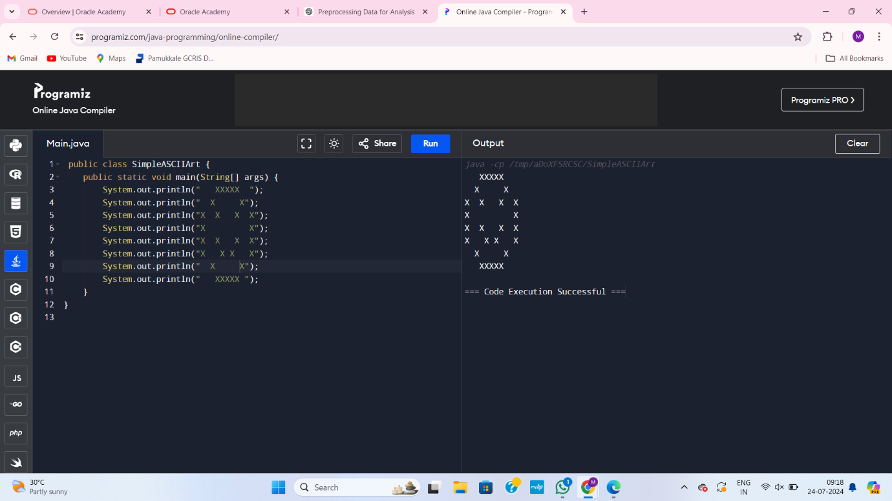

Problem 2: Original ASCII Art

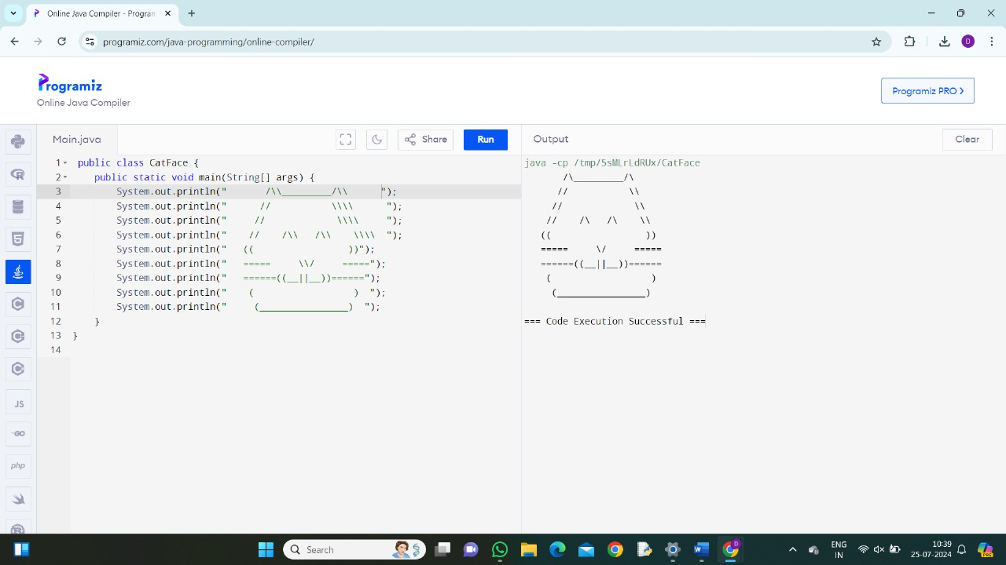

Problem 3: The Snake Box Factory

CREATE SNAKE BOX FACTORY SOFTWARE DESIGN

1. Object: SnakeBox

Properties:

Dimensions: The size of the box, typically including length, width, and height.

MaterialQuality: The quality of the cardboard used to make the box.

SnakeType: The specific type of snake that will be placed inside the box.

Behaviors:

CalculateBoxVolume(): Computes the volume of the box based on its dimensions.

CheckMaterialQuality(): Assesses the quality of the cardboard to ensure it meets standards.

AssignSnakeType(SnakeType type): Assigns a specific snake type to the box and adjusts any related settings.

2. Object: Snake

Properties:

Species: The species of the snake.

Size: The size of the snake, which may influence the size of the box required.

HealthStatus: The current health status of the snake.

Behaviors:

ChangeHealthStatus(String status): Updates the health status of the snake.

Grow(Size newSize): Adjusts the size attribute of the snake as it grows.

GenerateReport(): Creates a report on the snake’s current health and characteristics.

3. Object: Order

Properties:

OrderID: A unique identifier for each order.

CustomerDetails: Information about the customer placing the order, such as name and address.

OrderStatus: The current status of the order (e.g., Processing, Shipped, Delivered).

Behaviors:

UpdateOrderStatus(String newStatus): Changes the status of the order to reflect its current state.

GenerateInvoice(): Creates an invoice based on the details of the order.

TrackShipment(): Provides tracking information for the shipment of the order.